TARGET SQL BUSINESS CASE
Assuming you are a data analyst/ scientist at Target, you have been assigned the task of analysing the given dataset to extract valuable insights and provide actionable recommendations.
What does 'good' look like?
1. Import the dataset and do usual exploratory analysis steps like checking the structure & characteristics of the dataset:
1.A. Data type of all columns in the "customers" table
Select column_name, data_type
from scalar-dsml-450316.Target.INFORMATION_SCHEMA.COLUMNS
where table_name = 'customers';
OUTPUT-
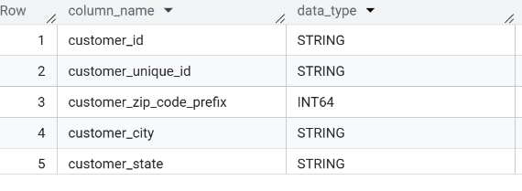
INSIGHT: - This gives us the data type used in column
1.B- Get the time range between which the orders were placed.
SELECT MIN (order_purchase_timestamp) AS first_order,
MAX (order_purchase_timestamp) AS last_order
from Target.orders;
OUTPUT-
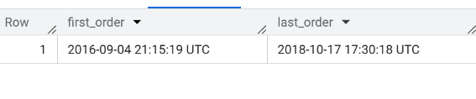
INSIGHT: - 1. From the data, first order is on 4-Sep-2016
2. From the data, last order is on 17-Oct-2016
RECOMMENDATION: If we will see the Duration of customer last order wherein, we can analyse the duration of purchase.

1. C. count the Cities & States of customers who ordered during the given period.
SELECT count (DISTINCT c. customer_city) AS city_cnt,
count (DISTINCT c.customer_state) AS state_cnt
FROM Target .customers AS c
INNER JOIN Target.orders AS o
ON c.customer_id = o.customer_id;
Output:
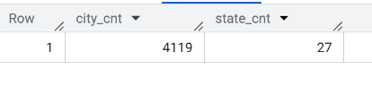
INSIGHT: This analysis will give the count of state and city count.
2. In-depth Exploration:
2.A Is there a growing trend in the no. of orders placed over the past years?
Select format date ('%Y-%m', order_purchase_timestamp) as year_ month,
count (*) as Total orders
from Target.orders
group by 1
order by 1;
Output:
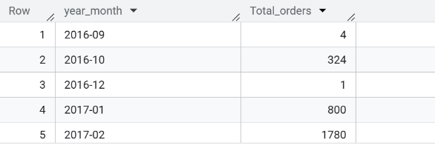
INSIGHT: The above data will give the Month wise Order details and year wise which will help us to know which month has less orders and root cause will be figured out for less order and accordingly the further improvements will be implemented.

2.B. Can we see some kind of monthly seasonality in terms of the no. of orders being placed?
Select format date ('%m', order_purchase_timestamp) as Month_d,
count (*) as Total orders
from Target.orders
Group by 1
Order by 1;
Output:-
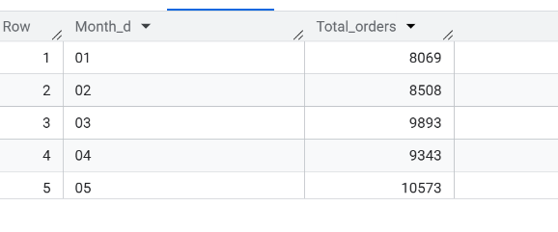
INSIGHT:-
This will give Month wise Total orders to analyse which month the order was more and that will be analysed and more discount and offer will be implanted accordingly for the increase in orders.
2.C. During what time of the day, do the Brazilian customers mostly place their orders? (Dawn, Morning, Afternoon or Night)
- 0-6 hrs : Dawn
- 7-12 hrs : Mornings
- 13-18 hrs : Afternoon
- 19-23 hrs : Night
SELECT
CASE
WHEN EXTRACT (HOUR FROM order_purchase_timestamp) BETWEEN 0 AND 6
THEN 'Dawn'
WHEN EXTRACT (HOUR FROM order_purchase_timestamp) BETWEEN 7 AND 12
THEN 'Morning'
WHEN EXTRACT (HOUR FROM order_purchase_timestamp) BETWEEN 13 AND 18
THEN 'Afternoon'
ELSE 'Night'
END AS Time_of_day,
COUNT (*) AS Total orders
FROM Target.orders
GROUP BY Time_of_day;
OUTPUT:-
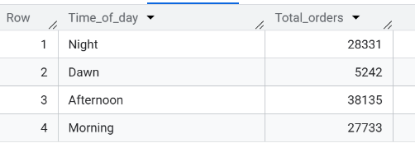
INSIGHT:- The above output will help to analyse at which hours of time do customer place less and more orders and it will help to deploy more support during the time.
Recommendation: As per data Afternoon customers are more active during afternoon hence we can deploy more ease of communication for better service and will work on the less order time how to implement more discount to increase the frequency.
3. Evolution of E-commerce orders in the Brazil region:
3. A. Get the month-on-month no. of orders placed in each state.
Sol- Select format_date ('%m', order_purchase_timestamp) as Month_wise, c.customer_state,
count (*) as Total_customer
From Target.orders o
Inner join Target.Customers c
on o.customer_id = c.customer_id
Group by 1,2;

OUTPUT:-
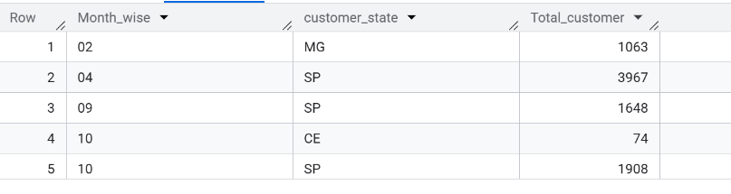
INSIGHT: This data will give the overview of month wise number of customer
Order the items which will help to Monthly analysis
RECOMMENDATION: Month wise if the data is monitored it will help to know new customers and retention of old customer.
3.B. How are the customers distributed across all the states?
SELECT
customer state AS state,
COUNT (DISTINCT customer_id) AS Total_customers
FROM customers
GROUP BY Customer_state
ORDER BY Total_customers DESC;
OUTPUT:-
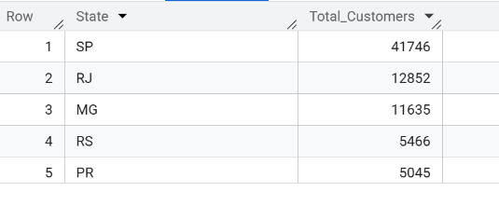
INSIGHT: - This analysis of finding state will help to know which state is ordering more to open more nearby HUB in that place.
RECOMMENDATION- Opening Multiple HUB result in fast delivery and quick service, which may lead to increase in orders and customer satisfaction.

4.Impact on Economy: Analyze the money movement by e-commerce by looking at order prices, freight and others.

4.A. Get the % increase in the cost of orders from year 2017 to 2018 (include months between Jan to Aug only).You can use the “payment value” column in the payments table to get the cost of orders.

with final as (SELECT EXTRACT (YEAR FROM o. order_purchase_timestamp) as Year,
sum (p. payment_value) as cost
from Target.orders AS o
Inner Join Target.payments As p
ON o. order_id = p.order_id
Where EXTRACT(MONTH FROM o.order_purchase_timestamp)BETWEEN 1 AND 8 AND
EXTRACT(YEAR FROM o.order_purchase_timestamp)IN (2017,2018)
GROUP BY Year
Order BY Year),
final2 AS (SELECT * ,LAG(cost) OVER(ORDER BY Year) as Lagg from final)
SELECT Year,ROUND( if null(((cost-lagg)/lagg)*100,0),2)as Percentage_increase
from final2
order by Year;
OUTPUT:
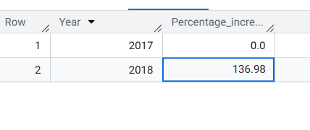
INSIGHT: This will give us the progress of business yearly and to figure out the status of company progress
RECOMMENDATION: Once we get to know about percentage increase yearly then it will help us set a new target for the upcoming year and analyse what factors lead to increase to work on.
4.B. Calculate the Total & Average value of order price for each state.
SELECT c. customer_state,
ROUND(sum(oi.price),2) as Total_price,
ROUND (sum(oi. price)/count (DISTINCT oi. order_id),2) as Avg_price
FROM Target.order_items as oi
INNER JOIN Target.orders AS o
ON oi.order_id = o.order_id
INNER JOIN Target. customers as c
ON c.customer_id = o.customer_id
GROUP BY c.customer_state;
OUTPUT:-
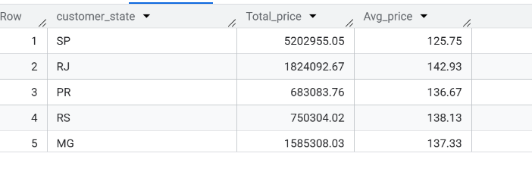
INSIGHT: This Output will help to analyse the Price
4.C. Calculate the Total & Average value of order freight for each state.
SELECT c.customer_state,
ROUND(sum(oi.freight_value),2) as total_freight_value
,ROUND(sum(oi.freight_value)/count(DISTINCT oi.order_id),2) as avg_freight_value
FROM Target.order_items as oi
INNER JOIN Target.orders AS o
ON oi.order_id = o.order_id
INNER JOIN Target.customers as c
ON c.customer_id = o.customer_id
GROUP BY c.customer_state;

OUTPUT:
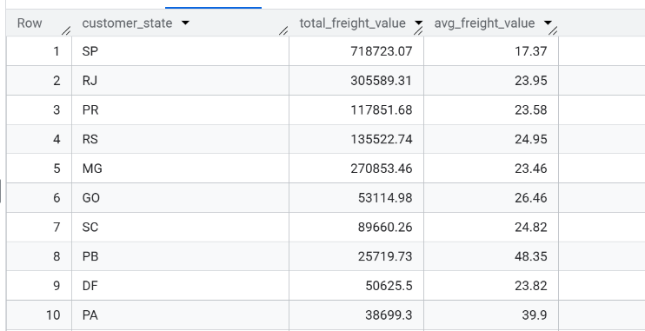

5.Analysis based on sales, freight and delivery time.
5.A. Find the no. of days taken to deliver each order from the order’s purchase date as delivery time.
Also, calculate the difference (in days) between the estimated & actual delivery date of an order. Do this in a single query.
You can calculate the delivery time and the difference between the estimated & actual delivery date using the given formula:
● Time_to_deliver = order_delivered_customer_date - order_purchase_timestamp
● Diff_estimated_delivery = order_delivered_customer_date -order_estimated_delivery_date
SELECT order_id,
DATE_DIFF(DATE(order_delivered_customer_date),
DATE(order_purchase_timestamp),DAY) as Time_to_deliver,
DATE_DIFF(DATE(order_delivered_customer_date),
DATE (order_estimated_delivery_date),DAY) as Diff_estimated_delivery
FROM Target.orders;OUTPUT:
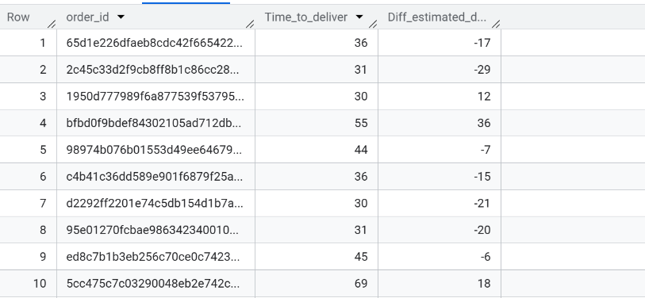

5.B. Find out the top 5 states with the highest & lowest average freight value.
SOL- WITH TOP_5 AS
(SELECT c.customer_state,
ROUND(sum(oi.freight_value)/count(DISTINCT oi.order_id),2) as avg_freight_value,
DENSE_RANK() OVER(ORDER BY ROUND(sum(oi.freight_value)/count(DISTINCT oi.order_id),2) DESC) as drnk
FROM Target.order_items as oi
INNER JOIN Target.orders AS o
ON oi.order_id = o.order_id
INNER JOIN Target.customers as c
ON c.customer_id = o.customer_id
GROUP BY c.customer_state),
BOTTOM_5 AS (SELECT c.customer_state,
ROUND(sum(oi.freight_value)/count(DISTINCT oi.order_id),2) as avg_freight_value,
DENSE_RANK() OVER(ORDER BY ROUND(sum(oi.freight_value)/count(DISTINCT oi.order_id),2)) as drnk
FROM Target.order_items as oi
INNER JOIN Target.orders AS o
ON oi.order_id = o.order_id
INNER JOIN Target.customers as c
ON c.customer_id = o.customer_id
GROUP BY c.customer_state)
SELECT customer_state,avg_freight_value
FROM TOP_5 WHERE drnk<=5
UNION ALL
SELECT customer_state,avg_freight_value
FROM BOTTOM_5 WHERE drnk <= 5 ORDER BY avg_freight_value DESC;
OUTPUT:-
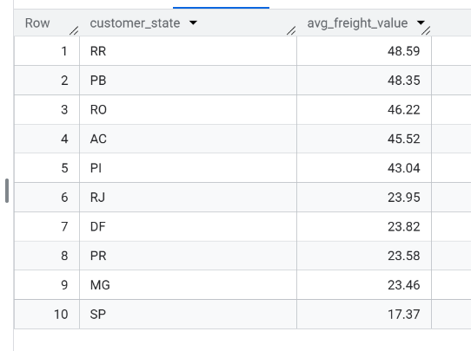
INSIGHT:
5.C. Find out the top 5 states with the highest & lowest average delivery time.
WITH RankedStates AS
( SELECT c.customer_state,
ROUND(AVG(DATE_DIFF(DATE(order_delivered_customer_date),
DATE(order_purchase_timestamp), DAY)), 2) AS avg_del_time,
DENSE_RANK() OVER(ORDER BY ROUND(AVG(DATE_DIFF(DATE(order_delivered_customer_date),
DATE(order_purchase_timestamp), DAY)), 2) DESC) AS rank_highest,
DENSE_RANK() OVER(ORDER BY ROUND(AVG(DATE_DIFF(DATE(order_delivered_customer_date),
DATE(order_purchase_timestamp), DAY)), 2)) AS rank_lowest FROM Target.orders AS o
INNER JOIN Target.customers AS c ON o.customer_id = c.customer_id
GROUP BY c.customer_state )
SELECT customer_state, avg_del_time
FROM RankedStates
WHERE rank_highest <= 5 OR rank_lowest <= 5
ORDER BY avg_del_time DESC;

OUTPUT:
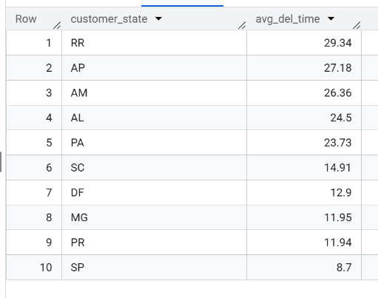
5.D. Find out the top 5 states where the order delivery is really fast as compared to the estimated date of delivery. You can use the difference between the averages of actual &estimated delivery date to figure out how fast the delivery was for each state.

SELECT c.customer_state
,ROUND(AVG(DATE_DIFF(DATE(order_estimated_delivery_date),
DATE(order_delivered_customer_date),Day)),2) AS Avg_delivery_days
FROM Target.orders AS o
INNER JOIN Target.customers AS c
ON o.customer_id = c.customer_id
GROUP BY c.customer_state
ORDER BY avg_delivery_days
LIMIT 5;

OUTPUT:-
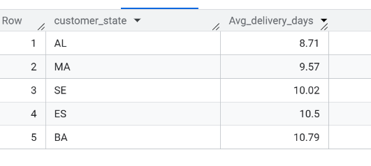

6.Analysis based on the payments.
6.A. Find the month on month no. of orders placed using different payment types.
SELECT p.payment_type,EXTRACT(MONTH FROM o.order_purchase_timestamp) as
Month,count(DISTINCT o.order_id) as no_of_orders
FROM Target.orders as o
INNER JOIN Target.payments as p
ON o.order_id = p.order_id
GROUP BY p.payment_type,Month
ORDER BY Month,no_of_orders DESC;
OUTPUT:-
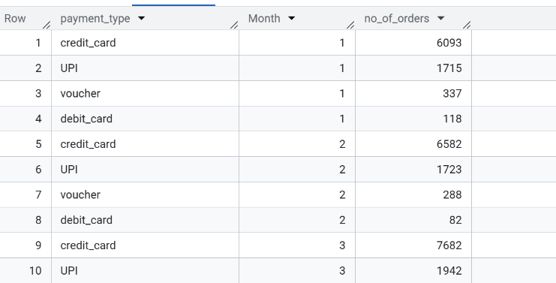
INSIGHT: This will give us the details of more ease of payment method for customers

6.B. Find the no. of orders placed on the basis of the payment instalments that have been paid.
SELECT payment_installments AS Installments,
COUNT(order_id) AS No_of_orders
FROM Target.payments AS o
WHERE payment_installments >= 1
GROUP BY payment_installments
ORDER BY no_of_orders DESC;
OUTPUT:-
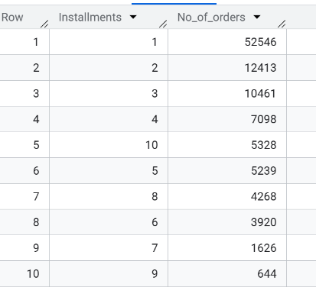

VALUABLE INSIGHTS
Order Trends:
●There is a visible year-on-year increase in orders placed, indicating growth in e-commerce adoption.
●Monthly seasonality could indicate peak periods for sales with the highest increase in sales in the month of November.
Customer Behaviour
A significant variation is observed in the delivery times across states. The average delivery time and deviations from estimated delivery times highlight areas for improvement in logistics.
●Top 5 states (SC,DF,MG,PR,SP) with the fastest deliveries show operational efficiency, while others may require optimization.
●The top 5 states with highest freight values are RR,PB,RO,AC,PI.
RECOMMENDATION:
● Improve logistics and delivery services in states with low order volume.
●The warehouse locations should be expanded for better delivery coverage.
● The low order states should be targeted to increase brand awareness and reason for low order.
● Discount and offers should be encouraged in state with less orders
●Promote the most convenient and popular method of payment to bo

